Noah Smith

CIS 310-02

8/21/2019

Week 2 Homework

1. The two tables have a one-to-many relationship. The table is this way due to the design, since an agent can have multiple customers, then on the customers table there will be many different repeated agent codes. This is set up within the business and is why the tables are set up this way. The business also seems to be following a style for the codes and insurance types.
2. 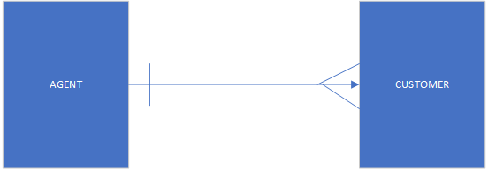
3. 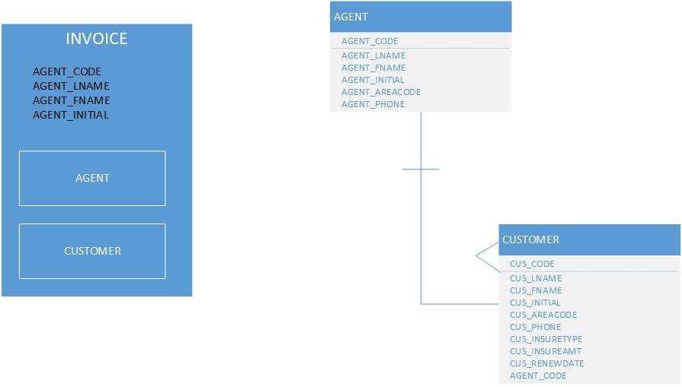
4. Region to Store has a one-to-many relationship. There can be multiple stores in a single region. The same could be said about store to employee and employee to job. There can be multiple employees at the same store and multiple jobs at the same store.

6. Course to Class is one-to-many, there can be multiple classes with the same course. Enroll and Class seems to be one-to-one. When you enroll in a class you can only enroll to it once, but Enroll to student would be many-to-many as multiple students can be enrolled into multiple places at once.

7.

8.